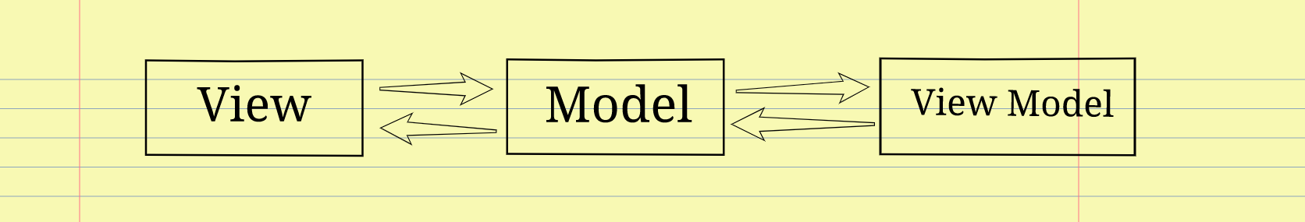

MVVM: It’s Stand for Model View View-Model Architecture

1. View - The View represents the user interface of the application, which display data to user and allow the user to interact with it.  Also sends the user action to the ViewModel but does not receive the response back directly.
2. Model - It represents the business logic and the data of an Application. It also consists of the business logic. It cannot directly talk to the View.
3. ViewModel - It acts as a link between the Model and the View. It’s responsible for transforming the data from the Model. it doesn't have any idea about which View it has to use as it does not possess a direct reference with the View. Hence, the ViewModel isn't aware of the view that it is interacting with.